**A Training Report on**

**Python Basics**

Organized by

**University of Michigan (Coursera)**

Submitted in partial fulfilment of award of

**BACHELOR OF TECHNOLOGY**

Degree In  
  
**Computer Science & Engineering**

By

**(Sarthak Srivastava)**

**(2000820100124)**

Under the Guidance of

**(Vibhor Kr. Vishnoi)**

**Assistant Professor**



**Dept. Of Computer Science & Engineering**

**Moradabad Institute of Technology ,Moradabad (U.P)**

**Session:2021-22**

**MORADABAD INSTITUTE OF TECHNOLOGY**

**Department of Computer Science & Engineering**

**CERTIFICATE**

Certified that the Industrial Training entitled “**PYTHON BASICS** submitted by **Sarthak Srivastava** Roll Number – **2000820100124** in their own work and has been carried under my supervision. It is recommended that the candidates may now be evaluated their industrial training work by the university .

**Date: Mr. Vibhor Kr. Vishnoi**

**Place: (Assistant Professor)**

**ABSTRACT**

This course introduces the Python programming language to the participants. Python is a general purpose programming language that can be used to develop applications. Through this course, the participants learn python programming and greatly benefit from performing hands-on-exercises. Apart from this this, It is beneficial to write the lines of code by following the instructor and/or the provided hangouts. The instructor and his assistants will help the individuals with their questions and problems. The instructor will use a widow machine to cover the topics the participants are expected to bring their own laptops . The instructor and his assistants will be available to help the participants with their installation of the needed software for the workshop prior to the start of the workshop. The topics include creating loops, working with lists, tuples Editing ,breaking and joining etc .

**ACKNOWLEDGEMENT**

Apart my efforts, the success of any project depends largely on the encouragement and guidelines of many others. I take this opportunity to express my gratitude to the people who have been instrumental in the successful completion of this project. I express deep sense of gratitude to almighty God for giving me the strength for the successful completion of the project. I express my heartfelt gratitude to my parents for constant encouragement while carrying out this project. I gratefully acknowledge the contribution of the individuals who contributed in bringing this project up to this level, who continues to look after me despite my flaws ,I express my deep sense of gratitude to the luminary the Director, Moradabad Institute of Technology who has been continuously motivating and extending their helping hand to us. I express my sincere thanks to the HOD of the Moradabad Institute of Technology , for constant encouragement and the guidance provided during this project I am overwhelmed to express my thanks to The COUNCELLOR for providing me an infrastructure and moral support while carrying out this project in the school. My Sincere thanks to Mr. Vibhor Kr. Vishnoi, the Counsellor who guided me to prepare this report. At last, my sincere thanks to Ms. Richa Saxena and Ms. Prachi Gupta, Master In- charge, a guide, and a mentor who critically reviewed my project and helped in solving each and every problem, occurred during implementation of the project. The guidance and support received from all the members who contributed and who are contributing to this project, was vital for the success of the project. I am grateful for their constant support and help.

Sarthak Srivastava

(2000820100124)

**TABLE OF CONTENTS**

Process Report COURSERA Certificate

Certificate

Abstract

Acknowledgement

**Chapter Title Page No .**

**No .**

1. - **Introduction to the specialization 7 - 11**

1.1- Values and Data Types 7

1.2- Operators and Operands 7

1.3- Function Calls 7

1.4- Type Conversion Functions 8

1.5- Variables 8

1.6- Statements and Expressions 8

1.7- Updating Variables 9

1.8- Hard-coding 10

1.9- Input 10

1. **– Introduction – Objects and Turtle Graphics 12 - 18**

2.1- Our first Turtle Program 12

2.2- Repetition with a For Loop 12

2.3-  More Turtle Methods 14

2.4-  Common Turtle Errors 15

2.5- Syntax Errors 15  
 2.6- Runtime Errors 16

2.7- Sematic Errors 17  
 2.8- Know Your Error Messages 17

2.9- Incremental Programming 18

**3- Introduction – Sequence Mutation 19 - 21**

3.1-Strings 19  
 3.2 -Lists 19  
 3.3-Tuples 20 3.4-The Index Operator 20

3.5 -Concatenation and Repitition 20

3.6-Count and Index 21

3.7-Split and Join 21

**4 – Boolean Expression 22 - 24**

4.1- Boolean Values and Boolean Expressions. 22

4.2- Logical Operators 22

4.3-Precedence of Operators 22

4.4-Conditional Execution 23

4.5-Nested Conditions 23 4.6-Chained Conditionals 24

**5 – Project Report 25 - 26**

5.1- Overview 25

5.2- Steps to Follow 25

5.3- Project Code and Output 25

5.4- Conclusion 26

**CONCLUSION 27**

**BIBLIOGRAPHY 28**





**CHAPTER-1**

**Introduction to the Specialization**

**1.1 VALUES AND DATA TYPES**

|  |
| --- |
| A **value** is one of the fundamental things — like a word or a number — that a program manipulates. Some values are 5 (the result when we add 2 + 3), and “Hello, World!’. These objects are classified into different classes, or data types: 4 is an integer, and “Hello, World!” is a string, so-called because it contains a string or sequence of letters. You (and the interpreter) can identify strings |
| because they are enclosed in quotation marks.  We can specify values directly in the programs we write. For example we can specify a number as a **literal** just by (literally) typing it directly into the program (e.g., 5 or 4.32). In a program, we specify a word, or more generally a string of characters, by enclosing the characters inside quotation marks (e.g., “Hello, World!”).  You can’t directly see the internal representations of values. You can, however, use the print function to see a printed representation in the output window. |

**1.2 OPERATORS AND OPERANDS**

|  |
| --- |
| You can build complex expressions out of simpler ones using **operators**. Operators are special tokens that represent computations like addition, multiplication and division. The values the operator works on are called **operands**. The following are all legal Python expressions whose meaning is more or less |
| clear: |

20 + 32

5 ** 2  
(5 + 9) * (15 – 7)

**1.3 – FUNCTION CALL**

A function is a block of code that only runs when it is called. Python functions **return a value using a return statement**, if one is specified. A function can be called anywhere after the function has been declared. By itself, a function does nothing.

There are three types of functions in Python:

* Built-in functions, such as help() to ask for help, min() to get the minimum value, print() to print an object to the terminal,… You can find an overview with more of these functions
* User-Defined Functions (UDFs), which are functions that users create to help them out; And
* Anonymous functions, which are also called lambda functions because they are not declared with the standard def keyword.

**1.4 Type Conversion Functions**

Python defines type conversion functions like **int(), float(), str() to directly convert one data type into another**. This type of conversion is also called typecasting because the user casts (change) the data type of the objects. This function converts any data type into integer.

**1.5 VARIABLES**

One of the most powerful features of a programming language is the ability to manipulate **variables**. A variable is a name that refers to a value.

**Assignment statements** create new variables and also give them values to refer to.

**1.6 – STATEMENT AND EXPRESSIONS**

Expression statements. Expression statements are used (mostly interactively) **to compute and write a value**, or (usually) to call a procedure (a function that returns no meaningful result; in Python, procedures return the value None ). Other uses of expression statements are allowed and occasionally .

**1.7 UPDATING VARIABLES**

One of the most common forms of reassignment is an **update** where the new value of the variable depends on the old. For example,

x = x + 1

|  |
| --- |
| This means get the current value of x, add one, and then update x with the new |
| value. The new value of x is the old value of x plus 1. Although this assignment statement may look a bit strange, remember that executing assignment is a two- step process. First, evaluate the right-hand side expression. Second, let the variable name on the left-hand side refer to this new resulting object. The fact that x appears on both sides does not matter. The semantics of the assignment statement makes sure that there is no confusion as to the result. The visualizer makes this very clear. |

If you try to update a variable that doesn’t exist, you get an error because Python evaluates the expression on the right side of the assignment operator before it assigns the resulting value to the name on the left. Before you can update a variable, you have to **initialize** it, usually with a simple assignment. In the above example, x was initialized to 6.

Updating a variable by adding something to it is called an **increment**; subtracting is called **decrement**. Sometimes programmers talk about incrementing or decrementing without specifying by how much; when they do they usually mean by 1. Sometimes programmers also talk about **bumping** a variable, which means the same as incrementing it by 1.

Incrementing and decrementing are such common operations that programming languages often include special syntax for it. In Python += is used for incrementing, and-=for decrementing. In some other languages, there is even a special syntax ++ and – for incrementing or decrementing by 1. Python does not have such a special syntax. To increment x by 1 you have to write x += 1 or x = x + 1.

**1.8 HARD CODING**

**Hard coding** (also **hard-coding** or **hardcoding**) is the software development practice of embedding data directly into the [source code](https://en.wikipedia.org/wiki/Source_code) of a [program](https://en.wikipedia.org/wiki/Computer_program)or other executable object, as opposed to obtaining the data from external sources or generating it at [runtime](https://en.wikipedia.org/wiki/Run_time_(program_lifecycle_phase)). Hard-coded data typically can only be modified by editing the source code and [recompiling](https://en.wikipedia.org/wiki/Compiling) the executable, although it can be changed in [memory](https://en.wikipedia.org/wiki/Volatile_memory) or on disk using a [debugger](https://en.wikipedia.org/wiki/Debugger) or [hex editor](https://en.wikipedia.org/wiki/Hex_editor). Data that are hard-coded usually represent unchanging pieces of information, such as [physical constants](https://en.wikipedia.org/wiki/Physical_constant), [version numbers](https://en.wikipedia.org/wiki/Version_number) and static text elements. [Softcoded data](https://en.wikipedia.org/wiki/Softcoding" \o "Softcoding), on the other hand, encode arbitrary information through [user input](https://en.wikipedia.org/wiki/User_input), [text files](https://en.wikipedia.org/wiki/Text_files), [INI files](https://en.wikipedia.org/wiki/INI_file), HTTP server responses, configuration files, preprocessor macros, external constants, databases, command-line arguments, and are determined at runtime.

Sometimes, some values/strings are hard-coded in functions. For example in the following function, I define a “constant” comparing string and check against it.

Def foo(s):

c_string = “hello”

if s == c_string:

return True

return False

**1.9 – INPUT**

Our programs get more interesting if they don’t do exactly the same thing every time they run. One way to make them more interesting is to get **input** from the user. Luckily, in Python there is a built-in function to accomplish this task. It is called input.

N = input(“Please enter your name: “)

The input function allows the programmer to provide a **prompt string**. In the example above, it is “Please enter your name: “. When the function is evaluated, the prompt is shown (in the browser, look for a popup window). The user of the program can type some text and press return. When this happens the text that has been entered is returned from the input function, and in this case assigned to the variable n. Run this example a few times and try some different names in the input box that appears.

It is very important to note that the input function returns a string value. Even if you asked the user to enter their age, you would get back a string like “17”. It would be your job, as the programmer, to convert that string into an int or a float, using the int or float converter functions we saw earlier .

**CHAPTER – 2**

**Introduction – Objects and Turtle Graphics**

**2.1 – OUR FIRST TURTLE PROGRAM**

Using Turtle, we can easily draw in a drawing board. First we import the turtle module. Then create a window, next we create turtle object and using turtle method we can draw in the drawing board.

Example Code

# import turtle library

import turtle

my_window = turtle.Screen()

my_window.bgcolor(“blue”) creates a graphics window

my_pen = turtle.Turtle()

my_pen.forward(150)

my_pen.left(90)

my_pen.forward(75)

my_pen.color(“white”)

my_pen.pensize(12)

# creates a graphics window

**2.2 Repetition With A For Loop**

Repetition statements are called loops, and are used to repeat the same code multiple times in succession.

**While loops**

* while a *condition* is true, do some *task*.
* while loop is known as a *pretest* loop, which means it tests its condition *before* performing an iteration
* The *oolean_expression* in these formats is sometimes known as the **loop continuation condition**
* The loop body must be a block, or a single statement (like with the if-statements)
* **How it works**
  + The boolean expression is a test condition that is evaluated to decide whether the loop should repeat or not.
    - **true** means run the loop body again.
    - **false** means quit.

### Examples

**# This program calculates sales commissions.**

**# Create a variable to control the loop.**

**Keep_going = ‘y’**

**# Calculate a series of commissions.**

**While keep_going == ‘y’:**

**# Get a salesperson’s sales and commission rate.**

**Sales = float(input(‘Enter the amount of sales: ‘))**

**comm_rate = float(input(‘Enter the commission rate: ‘))**

**# Calculate the commission.**

**Commission = sales * comm_rate**

**# Display the commission.**

**Print ‘The commission is $%.2f’ % commission**

**# See if the user wants to do another one.**

**Keep_going = raw_input(‘Do you want to calculate another ‘ + \**

**‘commission (Enter y for yes): ‘)**

**2.3 – More Turtle Methods**

Here are a few more things that you might find useful as you write

range

programs that use turtles.

• Turtle methods can use negative angles or distances. So  
100) will move tess backwards, and tess.left(-30) turns her to the right. Additionally, because there are 360 degrees in a circle, turning 30 to the left will leave you facing in the same direction as turning 330 to the right! (The on-screen animation will differ, though — you will be able to tell if tess is turning clockwise or counter-clockwise!)

tess.forward(-

This suggests that we don’t need both a left and a right turn method — we could be minimalists, and just have one method. There is also a *backward* method. (If you are very nerdy, you might enjoy saying alex.backward(-100) to move alex forward!)

Reviewing a few basic facts about geometry and number lines, like we’ve done here is a good start if we’re going to play with turtles.

• A turtle’s pen can be picked up or put down. This allows us to move a turtle to a different place without drawing a line. The methods are up and down. Note that the methods penup and pendown do the same thing.

**2.4 – Common Turtle Errors**

1. Forgetting a Parenthesis

When you run the example above you’ll see how an error occurs. This is because we accidentally left off the “)” when we tell alex to move forward. This is a common error for programmers of any skill level – it’s easy to miss one and not notice! If you get a syntax error like this or – expecially in this textbook – one that says there was bad syntax on a line that isn’t visible to you then likely you’re missing a parenthesis, quotation, or bracket.

2. Issues with Variable Names

Sometimes we misspell a variable name, either by making it capitalized when it wasn’t previously capitalized or swiching letters around. Other times we accidentally refer to the wrong variable name.

**2.5 – Syntax Errors**

Python will find these kinds of errors when it tries to parse your program, and exit with an error message without running anything. Syntax errors are mistakes in the use of the Python language, and are analogous to spelling or grammar mistakes in a language like English: for example, the sentence Would you some tea? Does not make sense – it is missing a verb.

Common Python syntax errors include:

* leaving out a keyword
* putting a keyword in the wrong place
* leaving out a symbol, such as a colon, comma or brackets
* misspelling a keyword
* incorrect indentation
* empty block

Here are some examples of syntax errors in Python:

**myfunction(x, y):**

**return x + y**

**else:**

**print(“Hello!”)**

**if mark >= 50**

**print(“You passed!”)**

**if arriving:**

**print(“Hi!”)**

**esle:**

**print(“Bye!”)**

**if flag:**

**print(“Flag is set!”)**

**2.6 – Runtime Errors**

* A runtime error in a program is an error that occurs while the program is running after being successfully compiled.
* Runtime errors are commonly called referred to as *“bugs”* and are often found during the debugging process before the software is released.
* When runtime errors occur after a program has been distributed to the public, developers often release patches, or small updates designed to fix the errors.
* Anyone can find the list of issues that they might face if they are a beginner in [this article](https://www.geeksforgeeks.org/overcoming-common-problems-in-competitive-programming/).
* While solving problems on online platforms, many run time errors can be faced, which are not clearly specified in the message that comes with them. There are a variety of runtime errors that occur such as **logical errors**, **Input/Output errors**, **undefined object errors**, **division by zero errors**, and many more.

**Some examples of Python runtime errors:**

* division by zero.
* performing an operation on incompatible types.
* using an identifier which has not been defined.
* accessing a list element, dictionary value or object attribute which doesn’t exist.
* trying to access a file which doesn’t exist.

**2.7 – Sematic Errors**

A semantic error occurs **when a program works without raising an Exception, but gives a different than the expected result**. The underlying defects are usually more difficult to eliminate than defects that result in error messages .

**2.8 – Know Your Error Messages**

Many problems in your program will lead to an error message. For example as I was writing and testing this chapter of the book I wrote the following version of the example program in the previous section.

current_time_str = input("What is the current time (in hours 0-23)?")

wait_time_str = input("How many hours do you want to wait")

current_time_int = int(current_time_str)

wait_time_int = int(wait_time_int)

final_time_int = current_time_int + wait_time_int

print(final_time_int)

Can you see what is wrong, just by looking at the code? Maybe, maybe not. Our brain tends to see what we think is there, so sometimes it is very hard to find the problem just by looking at the code. Especially when it is our own code and we are sure that we have done everything right .

**2.9 – Incremental Programming**

In **incremental systems**, every measurement refers to a previously dimensioned position (point-to-point). Incremental dimensions are the distances between two adjacent points. An incremental movement moves A distance based on your current position.

**Start Small –** First of all, start your program small and kept that working instead of writing many lines without having the idea of whether the program is correctly working or there is some error in it.

**Keep It Working –** Now as our small part is working fine then we should start adding another small part of the program to our main program and check whether it works fine or not. If there is any error you can find it at the first. Once there is no error the keep repeating the second step until our problem is met.

By doing this we can avoid lots of error at the last time when we are compiling the entire code and we will be confused by the whole lots of error showing. Because we will be eliminating all the errors side by side when we add a small part of the program to our main code.

Basically we follow this method of programming unknowingly. It is one of the best method of programming that the programmers can practice in their daily code.

**CHAPTER – 3**

**INTRODUCTION – SEQUENCE MUTATION**

**3.1 – Strings**

* A string is a sequence of characters.
* A character is simply a symbol. For example, the English language has 26 characters.
* Computers do not deal with characters , they deal with numbers (binary). Even though you may see characters on your screen, internally it is stored and manipulated as a combination of 0s and 1s.
* This conversion of character to a number is called encoding, and the reverse process is decoding. ASCII and Unicode are some of the popular encodings used.

**3.2 – Lists**

A list is **an ordered and mutable Python container**, being one of the most common data structures in Python. To create a list, the elements are placed inside square brackets ([]), separated by commas. As shown above, lists can contain elements of different types as well as duplicated elements.

**How do I make a list into a string in Python**

**Python List Comprehension along with join() method** can be used to convert a list to a string. The list comprehension will traverse the elements element-wise and the join() method would concatenate the elements of the list to a new string and represent it as output.

**3.3 – Tuples**

Python tuples are **a data structure that store an ordered sequence of values**. Tuples are immutable. This means you cannot change the values in a tuple. Tuples are defined with parenthesis.

Given a list of tuples, you **open a file in write mode**. For each tuple in the list, you convert all of its elements into strings, join them by spaces to form the string, and write the string with a new line to the file. Then you close the file . In Python, Set is **an unordered collection of data type** that is iterable, mutable and has no duplicate elements. There are numerous ways that can be used to iterate over a Set.

**3.4 – The Index Operator**

The indexing operator (Python uses square brackets to enclose the index) **selects a single character from a string**. The characters are accessed by their position or index value. ... Note that the character at index 6 (or -8) is the blank character.

The indexing method means **the approach used to measure the amount of change, if any, in the index**. Some of the most common indexing methods include ratcheting (annual reset), and point-to-point .

**3.5 - Concatenation And Repitition**

In python, concatenations and repetitions are **supported** by sequence data types both mutable(list) and immutable(tuple, strings). Sequence types like range objects do not support concatenation and repetition.

Concatenation (+) and Repetition (*) in Python .

In python, concatenations and repetitions are supported by sequence data types both mutable(list) and immutable(tuple, strings). Sequence types like range objects do not support concatenation and repetition. Furthermore, Python containers that are non-sequence data types (such as sets or dictionaries) do not support concatenation and repetition operators. In this article, we will take a detailed look at concatenations and repetitions that are supported by sequence data types such as list, tuple, and strings.

**3.6 – Count And Index**

As you create more complex programs, you will find that some tasks are commonly done. Python has some built-in functions and methods to help you with these tasks. This page will cover two helpful methods for both strings and lists: count and index.

You’ve learned about methods before when drawing with the turtle module. There, you used.forward(50) and .color("purple") to complete actions. We refer to forward and color as methods of the turtle class. Objects like strings and lists also have methods that we can use.

**3.7 – Split And Join**

Two of the most useful methods on strings involve lists of strings. The split method breaks a string into a list of words. By default, any number of whitespace characters is considered a word boundary.

An optional argument called a **delimiter** can be used to specify which characters to use as word boundaries.

**CHAPTER – 4**

**BOOLEAN EXPRESSION**

**4.1 – Boolean Values And Boolean Expressions**

The Python type for storing true and false values is called bool, named after the British mathematician, George Boole. George Boole created *Boolean Algebra*, which is the basis of all modern computer arithmetic.

Boolean values are not strings!

It is extremely important to realize that True and False are not strings. They are not surrounded by quotes. They are the only two values in the data type bool. Take a close look at the types shown below.

**4.2 LOGICAL OPERATORS**

|  |
| --- |
| There are three **logical operators**: and, or, and not. The semantics (meaning) of these operators is similar to their meaning in English. For example, x > 0 and x < 10 is true only if x is greater than 0 *and* at the same time, x is less than 10. How would you describe this in words? You would say that x is between 0 and 10, not including the endpoints. |
| **4.3 PRECEDENCE OF OPERATORS**  Arithmetic operators take precedence over logical operators. Python will always evaluate the arithmetic operators first (** is highest, then multiplication/division, then addition/subtraction). Next comes the relational operators. Finally, the logical operators are done last. This means that the expression x*5 >= 10 and y-6 <= 20 will be evaluated so as to first perform the arithmetic and then check the relationships. The and will be done last. Many programmers might place parentheses around the two relational expressions, (x*5 >= 10) and (y-6 <= 20). It is not necessary to do so, but causes no harm and may make it easier for people to read and understand the code.  **4.4 CONDITIONAL EXECUTION**  In order to write useful programs, we almost always need the ability to check conditions and change the behavior of the program accordingly. **Selection statements**, sometimes also referred to as **conditional statements**, give us this ability. The simplest form of selection is the **if statement**. This is sometimes referred to as **binary selection** since there are two possible paths of execution.  The boolean expression after the if statement is called the **condition**. If it is true, then the indented statements get executed. If not, then the statements indented under the else clause get executed.  **4.5 NESTED CONDITIONALS**  One conditional can also be **nested** within another. For example, assume we have two integer variables, x and y. The following pattern of selection shows how we might decide how they are related to each other.  **if** x < y: print("x is less than y")  **else**:  **if** x > y: print("x is greater than y")  **else**: print("x and y must be equal")  The outer conditional contains two branches. The second branch (the else from the outer) contains another if statement, which has two branches of its own. Those two branches could contain conditional statements as well.  The flow of control for this example can be seen in this flowchart illustration.  Here is a complete program that defines values for x and y. Run the program and see the result. Then change the values of the variables to change the flow of control.  **4.6 CHAINED CONDITIONALS**  Python provides an alternative way to write nested selection such as the one shown in the previous section. This is sometimes referred to as a **chained conditional**.   |  | | --- | | **if** x < y: print("x is less than y") | | **elif** x > y: print("x is greater than y")  **else**: print("x and y must be equal") |   elif is an abbreviation of . Again, exactly one branch will be executed. There is no limit of the number of elif statements but only a single (and optional) final else statement is allowed and it must be the last branch in the statement.  page33image31222656 |
|  |

**CHAPTER-5**

**PROJECT DESCRIPTION**

**5.1 OVERVIEW**

I made QR Code Scanner by using Python

A quick response (QR) code is a type of barcode that can be read easily by a digital device and which stores information as a series of pixels in a square-shaped grid. QR codes are frequently used to track information about products in a supply chain and often used in marketing and advertising campaigns.

**5.2 STEPS TO FOLLOW**

* Install module ’QR-Code’ using pip.
* Import module ‘QR-Code’.
* Create an object of ‘QR-Code’ class .
* Add data in QR object using ‘add_data()’
* Create image of QR-Code and save it .

**5.3 PROJECT CODE AND OUTPUT**

Import qrcode

qr=qrcode.QRCode(

       version = 15,

        box_size = 10,

        border = 5

        )

data ='https://youtu.be/qpHWsIXNIRY'

qr.add_data(data)

qr.make(fit=True)

img=qr.make_image(fill='black',back_color ='white' )

img.save('text.png')

**By scanning this Qrcode, you will reach this video directly .**

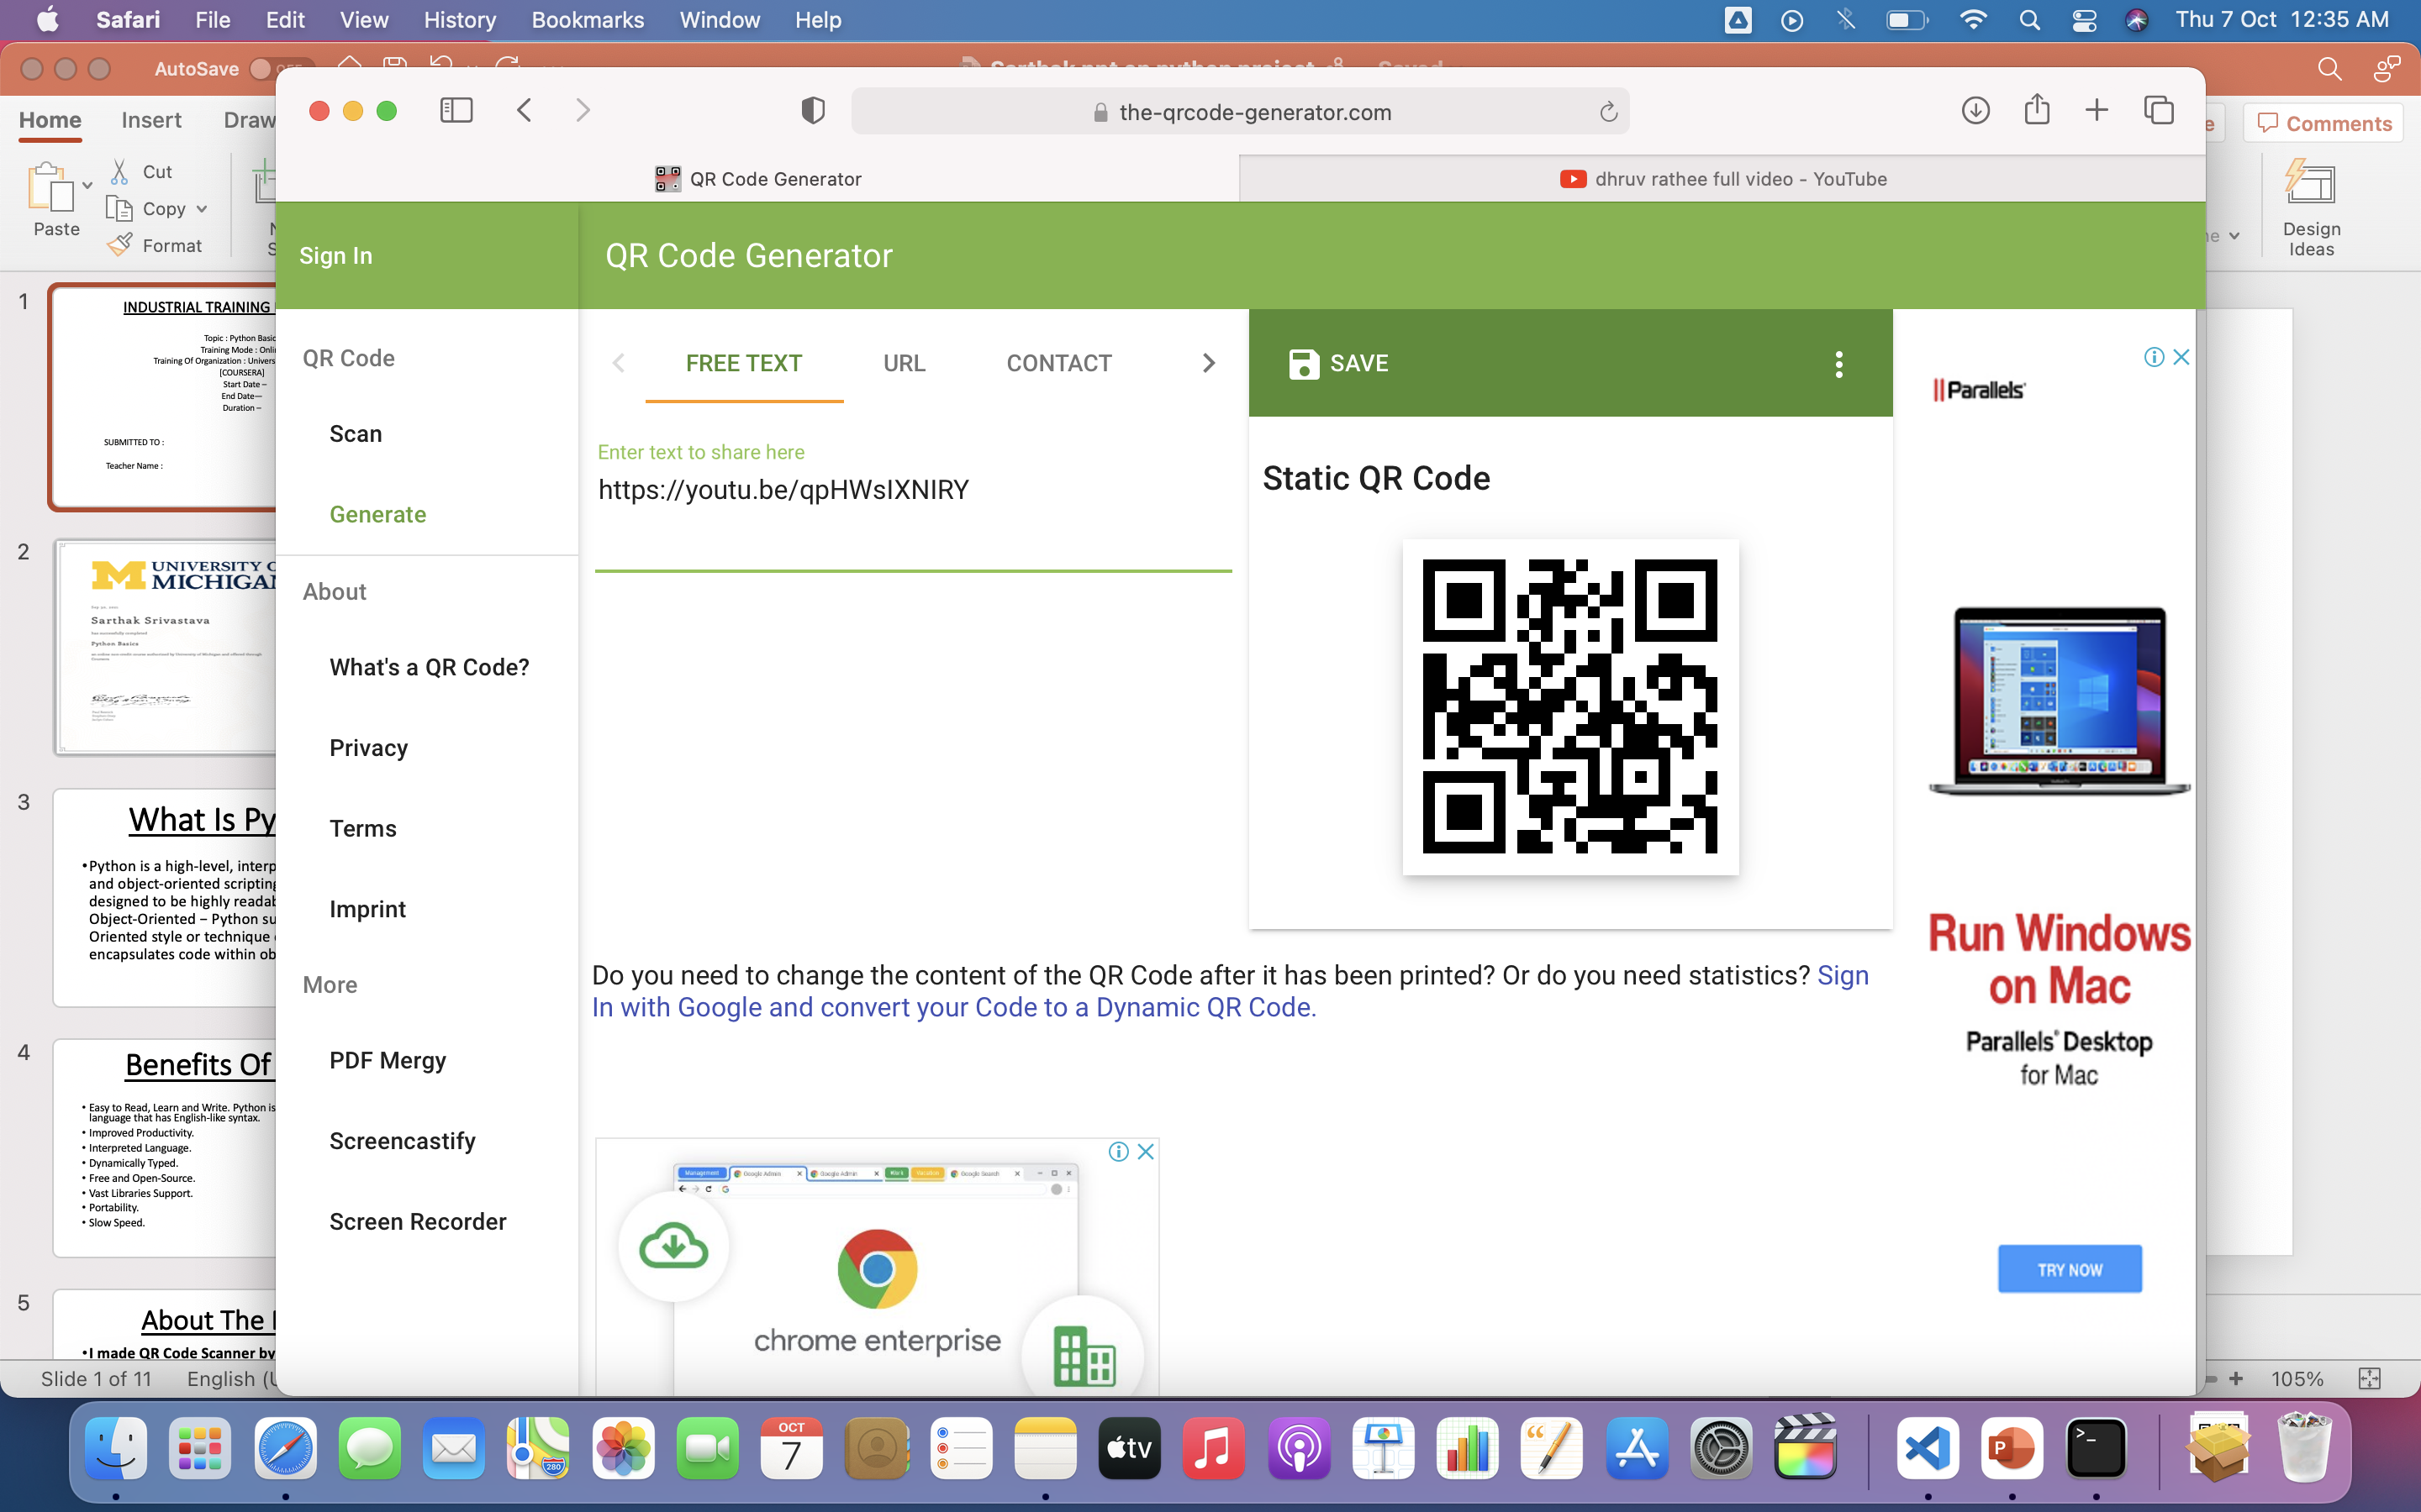 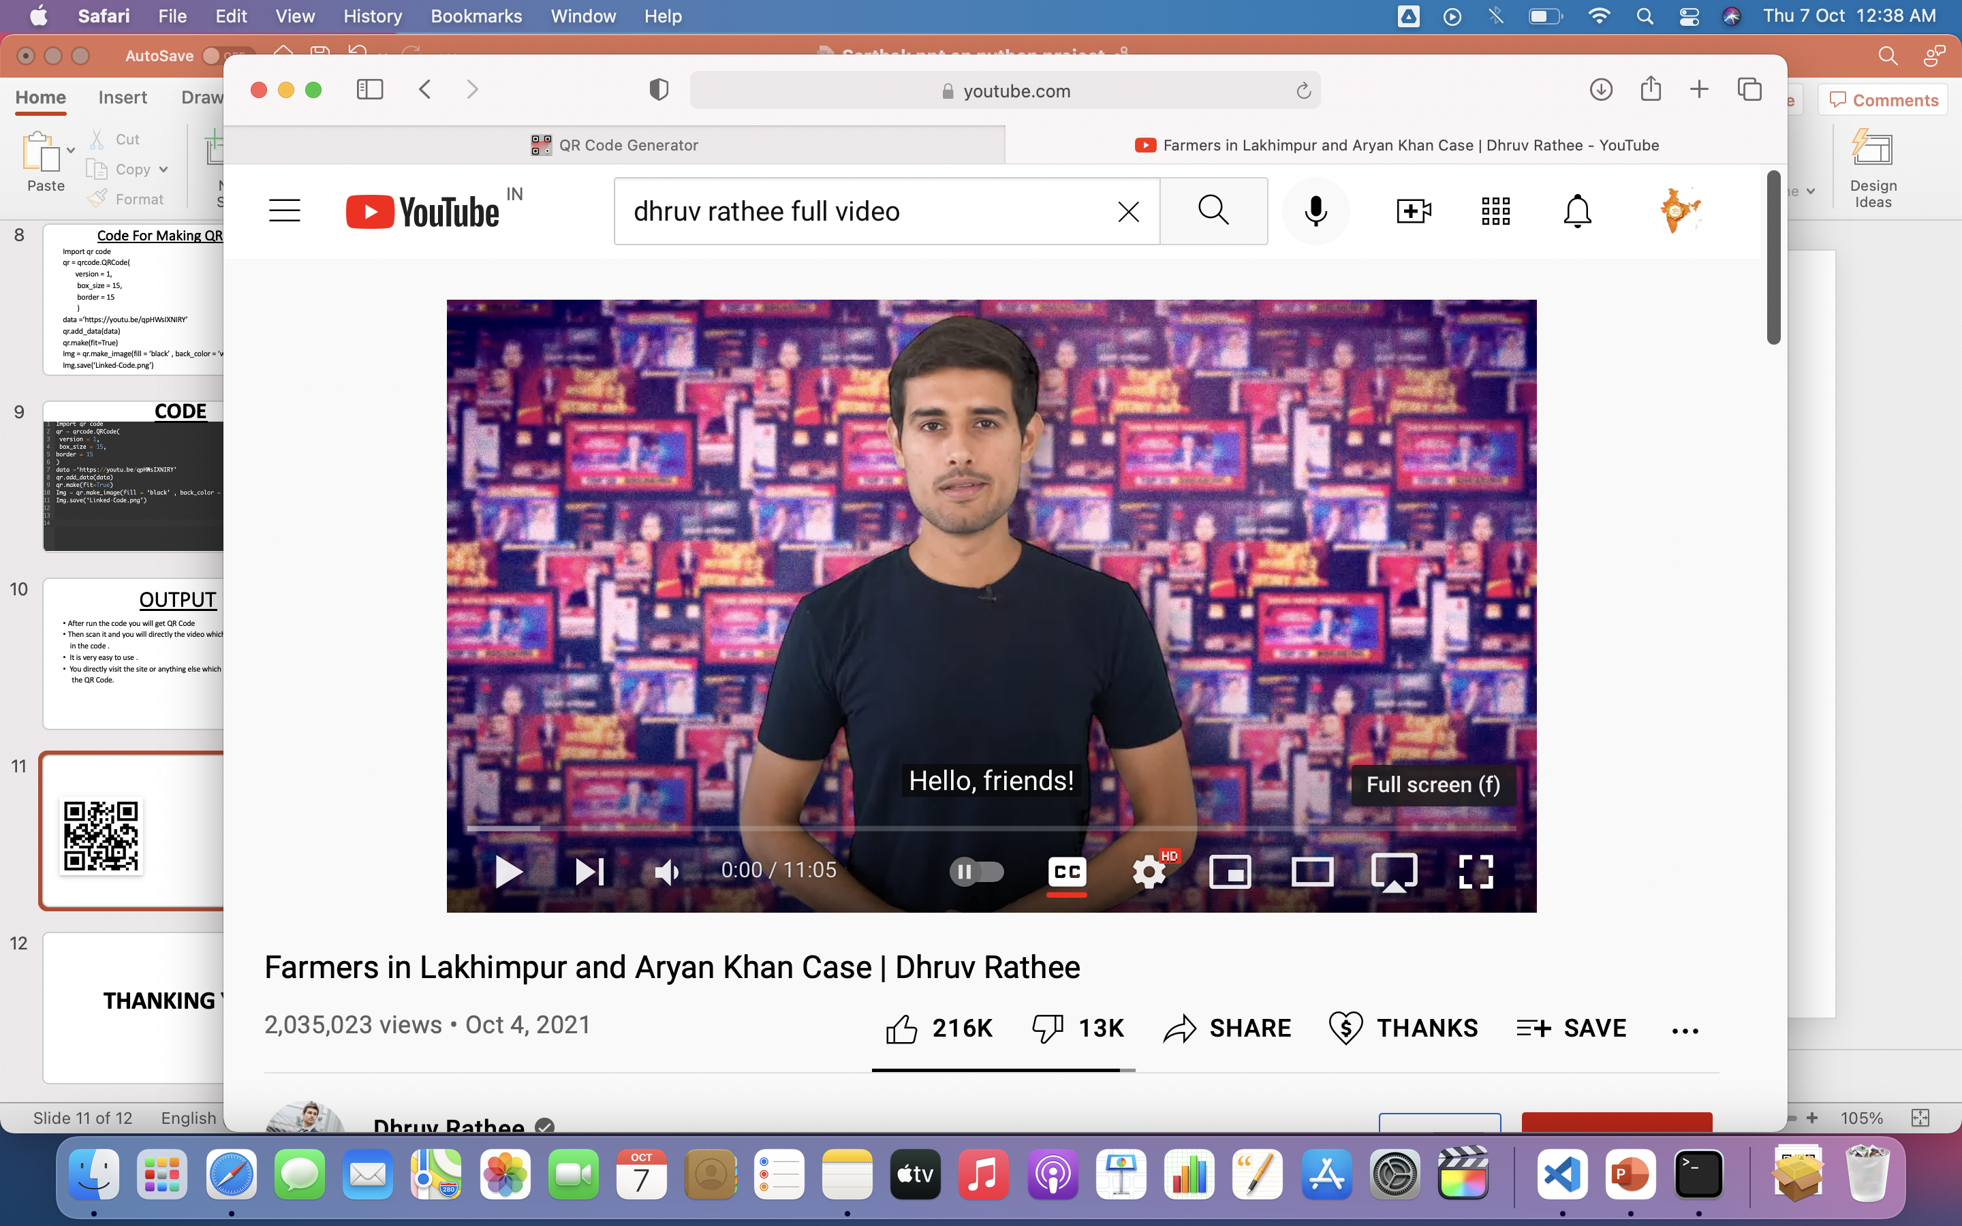

**5.4 CONCLUSION**

* After run the code you will get QR Code
* Then scan it and you will directly reach the video which I have instered in the code.
* It is very easy to use.
* You directly visit the site or anything else which you have need by the QR-Code.

**CONCLUSION**

This course introduces the basics of Python 3, including conditional execution and iteration as control structures, and strings and lists as data structures. You'll program an on-screen Turtle to draw pretty pictures. You'll also learn to draw reference diagrams as a way to reason about program executions, which will help to build up your debugging skills. The course has no prerequisites. It will cover Chapters 1-9 of the textbook "Fundamentals of Python Programming," which is the accompanying text (optional and free) for this course. The course is for you if you're a newcomer to Python programming, if you need a refresher on Python basics, or if you may have had some exposure to Python programming but want a more in-depth exposition and vocabulary for describing and reasoning about programs. This is the first of five courses in the Python 3 Programming Specialization.

**BIBLIOGRAPHY**

1 – [www.wikipedia.org](http://www.wikipedia.org)

2 – [www.coursera.in](http://www.coursera.in)

3- Coursera Notes

4- Reference books from college library